CHEMICAL ENGINEERING TRANSACTIONS  VOL. , 2024 | A publication of
The Italian Association
of Chemical Engineering
Online at www.cetjournal.it

Guest Editors: Leonardo Tognotti, Rubens Maciel Filho, Viatcheslav Kafarov
Copyright © 2024, AIDIC Servizi S.r.l.
ISBN 979-12-81206-09-0; ISSN 2283-9216
Neural network fuzzy predictive control for penicillin production from biomass
Bartolomeo Cosenzaª, Michele Miccio^{b}, Gabriele Pannocchiaª, Marco Vaccariª
ª Dipartimento di Ingegneria Civile e Industriale, Università di Pisa, Largo Lucio Lazzarino, 56122 Pisa (PI), Italy, {bartolomeo.cosenza,gabriele.pannocchia,marco.vaccari}@unipi.it
^{b} Dipartimento di Ingegneria Industriale (DIIn), Università degli Studi di Salerno, via Giovanni Paolo II 132, 84084 Fisciano (SA), Italy, michele.miccio@unisa.it

This work proposes, through simulations in the Matlab/Simulink software environment, a neural network predictive adaptive fuzzy control (NNPAFC) of a penicillin production process taking place in a batch-fed reactor. The results of such an implementation are presented and discussed. The outcomes of the simulations under realistic process control conditions confirm that this control strategy is, more than the others, a suitable strategy for the production of penicillin. This will ensure the production of high-quality penicillin and, at the same time, guarantee high production rates, maximizing penicillin yield, and minimizing waste of raw materials and production time.
  - Introduction
Industrial fermentation employs microorganisms to produce valuable compounds on a large scale, offering benefits such as greater environmental sustainability compared to conventional chemical processes (Lee et al. 2023). One of the most famous examples is the production of penicillin. This antibiotic, vital in the treatment of many diseases, is produced through the fermentation process using the Penicillium fungus. Discovered by Alexander Fleming in 1928, penicillin has been instrumental in treating a wide range of bacterial infections, saving countless lives and revolutionizing medicine. Its broad medical applications, from common infections to severe diseases, make it a cornerstone of antibiotic therapy. Penicillin's discovery paved the way for the development of numerous other antibiotics, shaping modern medicine and significantly impacting public health (Letek, 2023, Wilson, 2019). Beyond its medical importance, penicillin also finds applications in industrial processes, further underscoring its versatility and significance (Barresi, 2012).
Overall, penicillin's production is a key contributor to the effective management of bacterial infections, playing a pivotal role in healthcare and public well-being. The winning production strategy for penicillin production uses the fed-batch reactor (Liu, 2020; Mhaskar et al., 2018). It allows precise control of the nutrient concentration in the culture medium, manages biomass growth, and regulates the oxygen concentration to optimize growth conditions and production of penicillin-producing microorganisms. This approach leads to a higher production yield compared to other fermentation systems, ensuring an efficient and controlled process. Furthermore, the ability to gradually add nutrients during fermentation helps maintain optimal conditions for penicillin production.
Unlike continuous processes, fed-batch reactors do not involve continuous removal, allowing the volume to steadily increase until reaching the maximum allowable limit or completing the biological process (Bolmanis et al., 2023; Lim and Shim, 2013). However, the dynamic and nonlinear characteristics of biological systems in fed-batch fermentation processes pose challenges for effective control.
Liu and Gong (2016) explored systematically, the optimal controls under different mathematical models in fermentation processes. Brignoli et al. (2020) presented a novel feedforward-feedback controller logic to counter the problem of noise and oscillations in the control variable and to address the exponential growth dynamics more effectively. Duran-Villalobos et al. (2020) presented an advanced batch-to-batch optimization method designed to converge the yield toward a desired set-point over successive batches. Additionally, these authors introduced a new model predictive control technique to mitigate yield variability. Testing of this control method on an industrial-scale fed-batch penicillin simulator showed improved yields compared to standard operation. A nonlinear model predictive controller (MPC) was implemented in a Penicillium chrysogenum fed-batch process by Kager et al. (2020). These authors compared the MPC to a PI(D) and an open loop feedback control scheme. The controllers were used to maintain predefined set-points of biomass-specific glucose uptake rates, product precursor, and nitrogen concentrations by manipulating the glucose, precursor, and nitrogen feeds. Kim et al. (2021) proposed a two-stage optimal control framework for a fed-batch bioreactor. The high-level controller is designed to derive the optimal feed trajectory, aiming to maximize both final time productivity and yield through the utilization of a nominal model. Conversely, the low-level controller is responsible for sustaining the high-level performance despite discrepancies between the model and the actual plant, as well as handling real-time disturbances. Chai et al. (2022) reviewed the application of MPC in different fermentation processes with different selections of the manipulated and controlled variables. Bolmanis et al. (2023) compared the most popular open- and closed-loop methods for substrate feed rate control in fed-batch fermentations. Rashedi et al. (2023) used a model predictive controller (MPC) to compute an optimal feeding strategy leading to maximized cell growth and metabolite production in fed-batch cell culture processes. The lack of high-fidelity physics-based models and the high complexity of cell culture processes motivated the authors to use machine learning algorithms in the forecast model. Jones et al. (2023) described the development of improved control strategies for the standard environmental conditions in a fed-batch bioreactor used for monoclonal antibody cell culture. An optimal control of a nonlinear state-dependent impulsive system in the fed-batch process was proposed by Liu et al. (2023). More recently Espinel‐Ríos et al. (2024) fused cybernetics with model-based optimization and predictive control for optimizing dynamic bioprocesses. These authors formulated a model-based optimal control problem to find the optimal process inputs, focusing on fed-batch processes, where the substrate feeding rate is an additional optimization variable.
Penicillin fermentation typically occurs at temperatures between 25°C and 30°C. This is an optimal temperature range for the growth and production of penicillin by microorganisms, such as the fungus Penicillium chrysogenum, commonly used in the industrial production of penicillin.
During fermentation, microorganisms metabolize the substrates present in the fermentation broth, producing energy in the form of heat. High metabolic activity can generate heat and increase the temperature inside the reactor. If the temperature increases significantly above the optimal range for penicillin fermentation, this can have several effects on the production and growth of microorganisms as: denaturation of proteins, inhibition of microbial growth (reducing the total amount of penicillin produced), changes in product composition (leading to a production of unwanted metabolites or a reduction in penicillin yield), and contamination risks (high temperatures can encourage the growth of unwanted microorganisms or contaminants in the reactor, compromising the purity of the final product).
Methods for controlling temperature include the use of heating or cooling systems such as heat exchangers, cooling or heating tanks, and thermostats. Automation via temperature sensors and control systems allows for continuous temperature monitoring and rapid adjustment to maintain optimal conditions throughout the entire fermentation process.
  - Materials and methods
    - Fed-batch fermenter model
The authors adopt here the mathematical model proposed by Birol et al. (2002) for the temperature control of the fed-batch reactor in which penicillin production takes place. The proposed model constitutes an extension of the Bajpai and Reuss (1980) model, which previously demonstrated good agreement with experimental results. The mathematical model, although not recent, is sufficiently detailed to still be used today as a test bed for various applications. It is fundamentally based on the nine differential equations that follow: the biomass (X) growth rate (eq.1), the production of penicillin (P) (eq.2), the substrate glucose and dissolved oxygen balances (eqs.3,4) in terms of their concentrations (S) and C_{L}, respectively, the volume (V) balance (eq.5), the relation between the hydrogen ion concentration $\left[H^{+}\right]$ and the biomass formation (eq.6), the volumetric heat production rate (Q_{rxn}) (eq.7), the energy balance (eq.8) giving the temperature (T) evolution, and the generation of carbon dioxide CO₂ (eq.9).

$\frac{dX}{dt}=μX-\frac{X}{V}\frac{dV}{dt}$ (1)
$\frac{dP}{dt}=μ_{pp}X-KP-\frac{P}{V}\frac{dV}{dt}$ (2)
$\frac{dS}{dt}=-\frac{μ}{Y_{x/s}}X-\frac{μ_{pp}}{Y_{p/s}}X-m_{x}X+\frac{FS_{f}}{V}-\frac{S}{V}\frac{dV}{dt}$ (3)
$\frac{dC_{L}}{dt}=-\frac{μ}{Y_{x/o}}X-\frac{μ_{pp}}{Y_{p/o}}X-m_{o}X+K_{1a}\left(C_{L}^{*}-C_{L}\right)-\frac{C_{L}}{V}\frac{dV}{dt}$ (4)
$\frac{dV}{dt}=F+F_{a/b}-F_{loss}$ (5)
$\frac{d\left[H^{+}\right]}{dt}=γ\left(μX-\frac{FX}{V}\right)+\left[\frac{-B+\sqrt{\left(B^{2}+4*10^{-14}\right)}}{2}-\left[H^{+}\right]\right]\frac{1}{Δt}$ (6)
$\frac{dQ_{rxn}}{dt}=r_{q_{1}}\frac{dX}{dt}V+r_{q_{2}}XV$ (7)
$\frac{dT}{dt}=\frac{F}{s_{f}}\left(T_{f}-T\right)+\frac{1}{vρc_{p}}\left[Q_{rxn}-\frac{aF_{c}^{b+1}}{F_{c}+\left(aF_{c}^{b}/2ρ_{c}c_{pc}\right)}\right]$ (8)
$\frac{dCO_{2}}{dt}=α_{1}\frac{dX}{dt}+α_{2}X+α_{3}$ (9)
with:
$μ=\left[\frac{μ_{x}}{1+\left(K_{1}/\left[H^{+}\right]\right)+\left(\left[H^{+}\right]/K_{2}\right)}\right]\frac{S}{K_{x}X+S}\frac{C_{L}}{K_{ox}X+C_{L}}\left[k_{g}\exp\left(-\frac{E_{g}}{RT}\right)\right]-\left[k_{d}\exp\left(-\frac{E_{d}}{RT}\right)\right]$ (10)

$μ_{pp}=μ_{p}\frac{S}{\left(K_{p}+S+S^{2}/K_{I}\right)}\frac{C_{L}^{p}}{K_{op}X+C_{L}^{p}}$ (11)
$F_{loss}=Vλ\left(e^{5\left(\left(T-T_{0}\right)/\left(T_{v}-T_{0}\right)\right)}-1\right)$ (12)
$B=\frac{\left[10^{-14}/\left[H^{+}\right]-\left[H^{+}\right]\right]V-C_{a/b}\left(F_{a}+F_{b}\right)Δt}{V+\left(F_{a}+F_{b}\right)Δt}$ (13)

For details, numerical values, ​​and algebraic expressions of the parameters, please refer to Birol et al. (2022).
In this work, the issue of temperature control of the penicillin fermentation process, which takes place in a well-mixed fed-batch reactor, will be addressed.

2.2 Control strategy
The above mathematical model was implemented as an object-oriented software code in Simulink.
First, an open loop simulation of the fed-batch reactor was run. The time evolution of temperature in the well-mixed reactor is reported in Figure 1 under the dynamic situation typical of a fed-batch operation started at ambient temperature (T_{f} = 297 K).
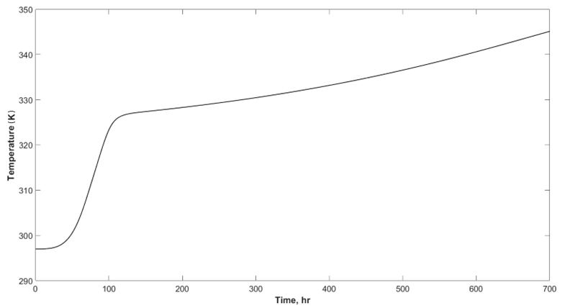
Figure.1 Temperature evolution of the open loop system (fed-batch reactor) as a function of time.

As can easily be seen from Figure 1, the absence of a reactor temperature control system leads to a monotonic increase in temperature, even far beyond the optimal operating range, with all the negative consequences that this entails. It is therefore necessary to act with a valid and effective control action.
The control system was implemented in Simulink, using fuzzy logic control systems and the Neural Network Predictive Controller (NNPC). NNPC is a type of advanced controller used in a wide range of applications, from manufacturing industries to robotics to chemical process control. Its peculiarity lies in the use of artificial neural networks to model and predict the dynamic behavior of the system to be controlled, allowing more precise and dynamic regulation compared to traditional control methods.
When implemented in Simulink, NNPC leverages the power of the software for simulating dynamic systems and interfacing with trained neural networks. Initially, it is necessary to acquire data from the system to be controlled for training the artificial neuron model. This can be done by simulating the system (see Figure 2) or using real experimental data. In this case, the training of the NNPC occurs by taking the model of the uncontrolled system as a reference and considering the seventh input of the system, the feed rate F_{c} of the cooling fluid, as input and the eighth output of the system, the temperature T inside the reactor, as output (eq. 8). Once the neural network has been trained, it can be integrated within the Simulink simulator to train the predictive controller. As typical of MPC, the controller uses the neural network to predict the future behavior of the system based on current conditions and possible control actions. In Simulink, the NNPC is typically implemented as a control block (Figure 3A) that accepts as input the outputs of the system on which control is exercised and the related setpoint and returns the control actions (via manipulation variable) to be applied to the system. NNPC offers several advantages over traditional control methods. It can manage non-linear and complex systems with greater effectiveness ensuring optimal performance even in the face of unexpected changes.
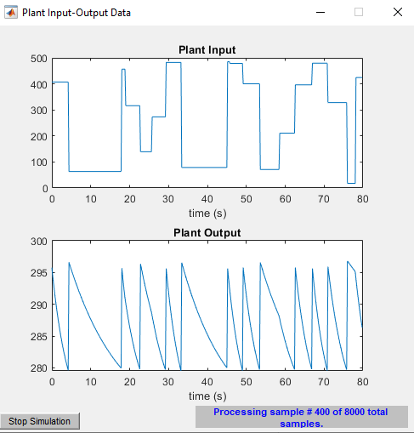
Figure.2. Graphical interface that shows the generation of data useful for training the neural network.
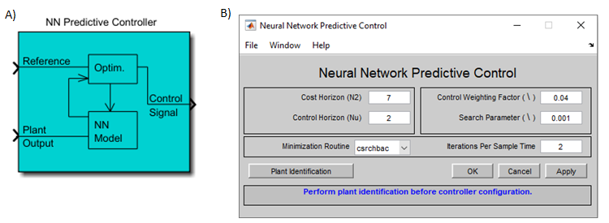
Figure.3. Neural Network Predictive Controller: A) Simulink block. B) graphical user interface.

The Block diagram proposed by the Authors for the MPC architecture of the fed-batch penicillin production process is shown in Figure 4. The chosen manipulation variable is the feed rate F_{c} of the cooling fluid, entering the energy balance (eq.8). As shown in the block diagram (Figure 4), the predictive neural control does not act autonomously, but in synergy with the fuzzy controller. Its role is to suitably modify the action of the fuzzy controller, adapting it appropriately. Therefore, the input signal to the fed-batch system will be that of the manipulation variable adapted by the action of the neural network predictive controller.

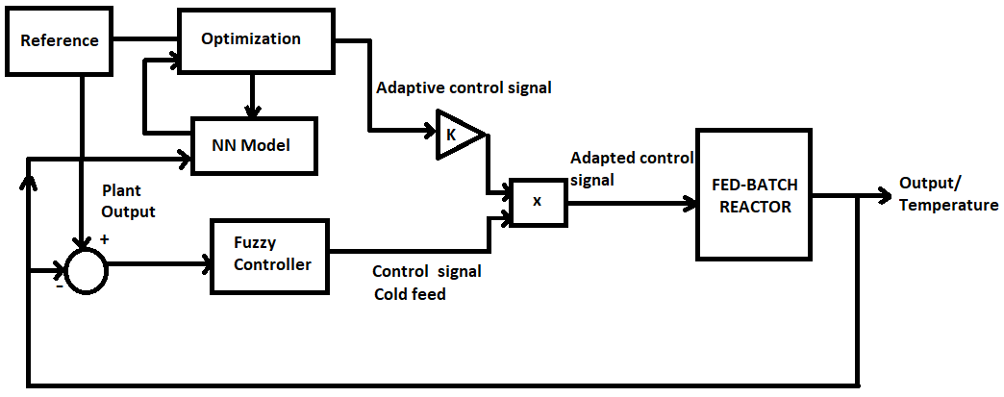
Figure.4 Block diagram of the control process.
  - Results
The results of some simulations obtained first at a constant set-point and then at a variable set-point are shown in the following. Figure 5 shows the temperature evolution over time for the system controlled by FLC and NNPAFC for a fed-batch operation started at T_{f} = 295 K. The set-point is set at 298 K.
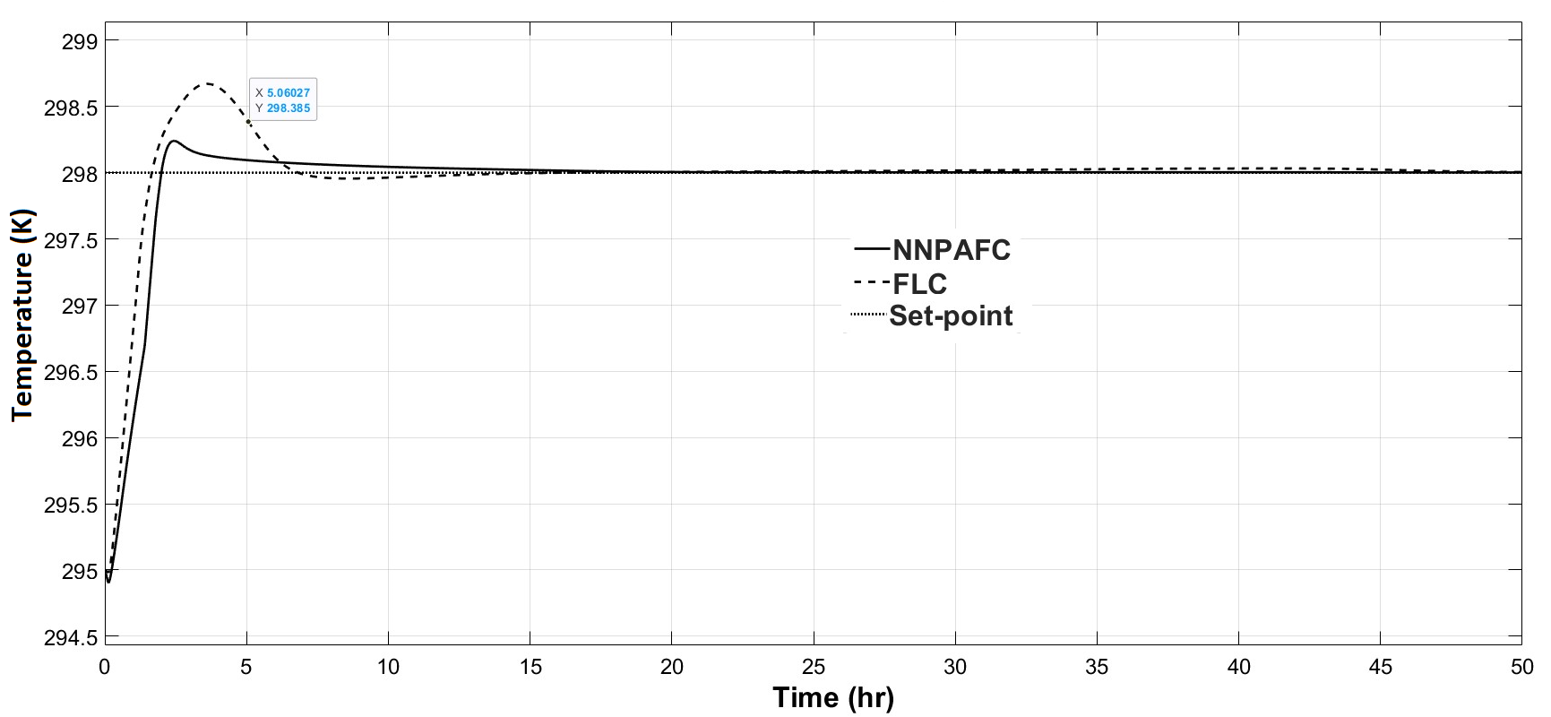
Figure.5 Temperature evolution of the system controlled by FLC and NNPAFC as a function of time with a constant set point = 298 K.
It is clear how the control system can maintain, in both cases, the desired value, avoiding that increase in temperature that the system foresees due to the metabolic actions of microorganisms, but the addition of the neural network predictive adaptive system to the fuzzy control brings benefits in terms of performance. In fact, in this case the system reaches the setpoint value a little earlier, with less overshoot than its non-adaptive counterpart. Given this, in the following two simulations only the performance of the system controlled by NNPAFC for step variations of the set point will be shown. The initial performance of the control system can be easily improved by modifying either the Control Weighting Factor (see Figure 3B) or the multiplicative constant K (see Figure 4). Figure 6 shows the trend of the controlled system when there is a descending step in the set-point, precisely from 298 to 296 K at time t = 20 hr.
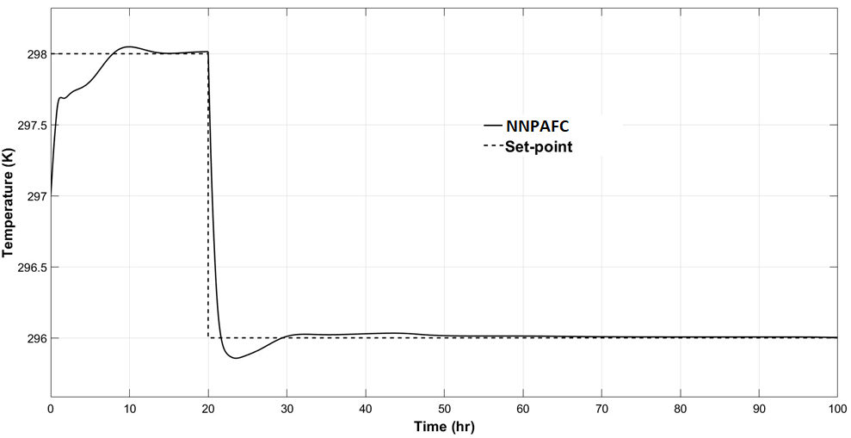
Figure.6 Temperature evolution of the system controlled by NNPAFC as a function of time with a step in the set point from 298 to 296 K at t = 20 hr.

Figure 7 shows the performance of the controlled system when there is an ascending step in the set-point, precisely from 298 to 300 K at time t= 20 hr. In both cases the fed-batch operation started at T_{f} = 297 K and the control system proves to be fast in response time and effective in limiting any underdamped oscillation.
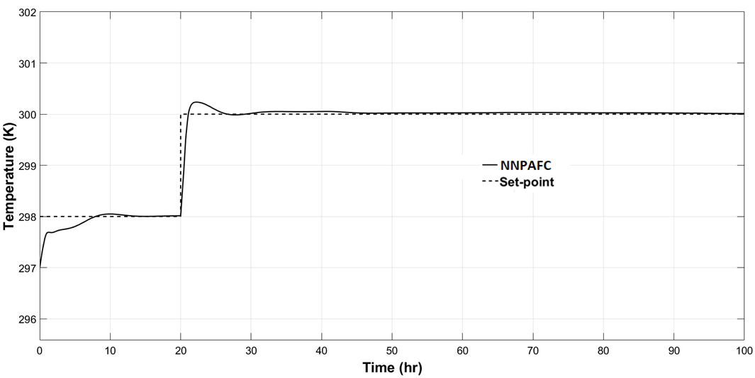
Figure.7 Temperature evolution of the system controlled by NNPAFC as a function of time with a step in the set point from 298 to 300 K at t = 20 hr.
  - Conclusions
The article presents an innovative neural network predictive adaptive fuzzy control scheme tested to regulate the temperature in a fed-batch reactor used in penicillin production. Simulation results show promising improvements in system performance compared to traditional fuzzy control methods. The proposed controller guarantees precise and rapid regulation of the process temperature. This translates into greater production efficiency and better quality of the final product. Furthermore, the promising outcomes attained in temperature regulation lay a solid foundation for contemplating the extension of this sophisticated control scheme to address the non-linear pH control within the fed-batch reactor system. Such an extension holds the promise of unlocking further optimization opportunities, thereby fostering greater reliability, sustainability, and competitiveness in pharmaceutical manufacturing processes. The successful adaptation of this methodology could potentially yield far-reaching benefits, including improved process stability, reduced variability, and enhanced control over critical parameters, contributing to the overall advancement of pharmaceutical production methodologies. The authors' next objective will be to verify the robustness of the proposed control system (and extended to pH control), evaluating how it behaves in the face of disturbances, uncertainties, and variations in the model parameters. Only after assessing its robustness it will be possible to test its effectiveness directly on a real system.
Acknowledgments
Project funded under the National Recovery and Resilience Plan (NRRP), Mission 4 Component 2 Investment 1.3 - Call for tender No. 1561 of 11.10.2022 of Ministero dell’Università e della Ricerca (MUR); funded by the European Union – NextGenerationEU: Award Number: Project code PE0000021, Concession Decree No. 1561 of 11.10.2022 adopted by Ministero dell’Università e della Ricerca (MUR), CUP - I53C22001450006, Project title “Network 4 Energy Sustainable Transition – NEST”.
References
Bajpai, R. & Reuss, M. (1980). A mechanistic model for penicillin production. Journal of Chemical Technology and Biotechnology 30, 330 /344.
Barresi, G. (2012). Penicillin: Biosynthesis, Applications, and Adverse Effects. Nova Science Publishers (US).
Birol, G., Undey, C., & Cinar, A. (2002). A modular simulation package for fed-batch fermentation: penicillin production. Computers and Chemical Engineering, 26,1553–1565.
Bolmanis E., Dubencovs K., Suleiko, A., & Vanags J. (2023). Model Predictive Control—A Stand Out among Competitors for Fed-Batch Fermentation Improvement. Fermentation, 9(3), 206.
Brignoli Y., Freeland B., Cunningham D., & Dabros M. (2020). Control of specific growth rate in fed-batch bioprocesses: novel controller design for improved noise management. Processes, 8(6), 679.
Chai W. Y., Teo K. T. K., Tan M. K., Tham H. J., 2022, Model predictive control in fermentation process–A review. In AIP Conference Proceedings (Vol. 2610, No. 1). AIP Publishing.
Duran-Villalobos, C. A., Goldrick, S., & Lennox, B. (2020). Multivariate statistical process control of an industrial-scale fed-batch simulator. Computers & Chemical Engineering, 132, 106620.
Espinel‐Ríos S., Morabito B., Pohlodek J., Bettenbrock K., Klamt S., & Findeisen R. (2024). Toward a modeling, optimization, and predictive control framework for fed‐batch metabolic cybergenetics. Biotechnology and Bioengineering, 121(1), 366-379.
Jones J., Kindembe D., Branton H., Lawal N., Montero E. L., Mack J., ... & Montague G. (2023). Improved control strategies for the environment within cell culture bioreactors. Food and Bioproducts Processing, 138, 209-220.
Kager J., Tuveri, A., Ulonska, S., Kroll, P., Herwig, C., 2020, Experimental verification and comparison of model predictive, PID and model inversion control in a Penicillium chrysogenum fed-batch process. Process Biochemistry, 90, 1-11.
Kim J. W., Park B. J., Oh T. H., Lee J. M., 2021, Model-based reinforcement learning and predictive control for two-stage optimal control of fed-batch bioreactor. Computers & Chemical Engineering, 154, 107465.
Lee J. A., Kim H. U., Na J. G., Ko Y. S., Cho J. S., & Lee S. Y., 2023. Factors affecting the competitiveness of bacterial fermentation. Trends in Biotechnology, 41(6), 798-816.
Letek M., 2023, Alexander Fleming, The discoverer of the antibiotic effects of penicillin. Behind a great medical drug there is always a great scientist!, 64.
Lim H. C., Shin H. S., 2013, Fed-Batch Cultures: Principles and Applications of Semi-Batch Bioreactors. Stati Uniti: Cambridge University Press.
Liu C., Shi G., Liu G., & Hu D. (2023). Optimal control of a nonlinear state-dependent impulsive system in fed-batch process. International Journal of Biomathematics, 16(08), 2350001.
Liu, S. (2020). Bioprocess Engineering: Kinetics, Sustainability, and Reactor Design. Paesi Bassi: Elsevier Science.
Liu, C., Gong, Z. (2016). Optimal Control of Switched Systems Arising in Fermentation Processes. Germania: Springer Berlin Heidelberg.
Mhaskar, P., Garg, A., Corbett, B. (2018). Modeling and Control of Batch Processes: Theory and Applications. Germania: Springer International Publishing.
Medina, R. (2019). Fermentation Technology. Regno Unito: EDTECH.
Omstead, D. R. (2020). Computer Control of Fermentation Processes. Stati Uniti: CRC Press.
Rashedi M., Rafiei M., Demers M., Khodabandehlou H., Wang T., Tulsyan A., ... & Garvin, C. (2023). Machine learning‐based model predictive controller design for cell culture processes. Biotechnology and Bioengineering, 120(8), 2144-2159.
Wilson, M. E. (2019). Antibiotics: What Everyone Needs to Know. Stati Uniti: Oxford University Press.

